**Concepts of Orthogonal Frequency Division Multiplexing (OFDM) and 802.11 WLAN**

It’s important to have a fundamental understanding of Orthogonal Frequency Division Multiplexing ([OFDM](javascript:void(0);)) because this technology is a basic building block for many of the current modulation schemes including; 802.11 [WLAN](javascript:void(0);), 802.16 WiMAX, and 3GPP LTE. This topic discusses the basic concepts of OFDM and how OFDM is implemented in 802.11a WLAN modulation. The basic OFDM principles will be introduced using a simple analog OFDM implementation and then those concepts will be extended to the digital domain with a simple digital OFDM implementation which utilizes the [FFT](javascript:void(0);) transform and DSP technology. The discussion ends with an explanation of how OFDM is implemented in 802.11a WLAN and how the OFDM symbol and burst is created.

**Introduction to OFDM - Orthogonal Frequency Division Multiplexing**

Orthogonal Frequency Division Multiplexing (OFDM) is a digital multi-carrier modulation scheme that extends the concept of single subcarrier modulation by using multiple subcarriers within the same single channel. Rather than transmit a high-rate stream of data with a single subcarrier, OFDM makes use of a large number of closely spaced orthogonal subcarriers that are transmitted in parallel. Each subcarrier is modulated with a conventional digital modulation scheme (such as [QPSK](javascript:void(0);), 16QAM, etc.) at low symbol rate. However, the combination of many subcarriers enables data rates similar to conventional single-carrier modulation schemes within equivalent bandwidths.

OFDM is based on the well-known technique of Frequency Division Multiplexing (FDM). In FDM different streams of information are mapped onto separate parallel frequency channels. Each FDM channel is separated from the others by a frequency guard band to reduce interference between adjacent channels.

The OFDM scheme differs from traditional FDM in the following interrelated ways:

1. Multiple carriers (called subcarriers) carry the information stream,

2. The subcarriers are orthogonal to each other, and

3. A guard interval is added to each symbol to minimize the channel delay spread and intersymbol interference.

The following figure illustrates the main concepts of an OFDM signal and the inter-relationship between the frequency and time domains. In the frequency domain, multiple adjacent tones or subcarriers are each independently modulated with complex data. An Inverse FFT transform is performed on the frequency-domain subcarriers to produce the OFDM symbol in the time-domain. Then in the time domain, guard intervals are inserted between each of the symbols to prevent inter-symbol interference at the receiver caused by multi-path delay spread in the radio channel. Multiple symbols can be concatenated to create the final OFDM burst signal. At the receiver an FFT is performed on the OFDM symbols to recover the original data bits.

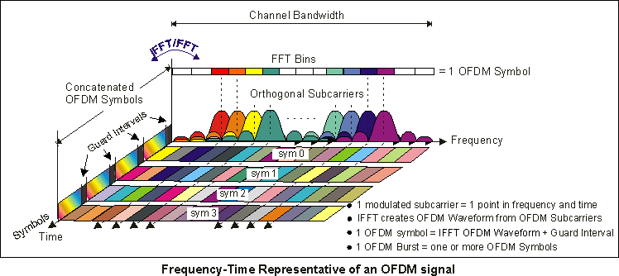

**Understanding OFDM**

**Simple Analog OFDM system Implementation**

We will use a simple analog based implementation to show the basic principles of generating an OFDM signal. In this simple OFDM system there are N sinusoidal input signals. Each subcarrier transmits one bit of information (N bits total) as indicated by its presence or absence in the output spectrum. The frequency of each subcarrier is selected to form an orthogonal signal set. These frequencies are also known at the receiver for signal recovery. Note that the output is updated at a periodic interval T that forms the symbol period. To maintain orthogonality, T must be the reciprocal of the subcarrier spacing.

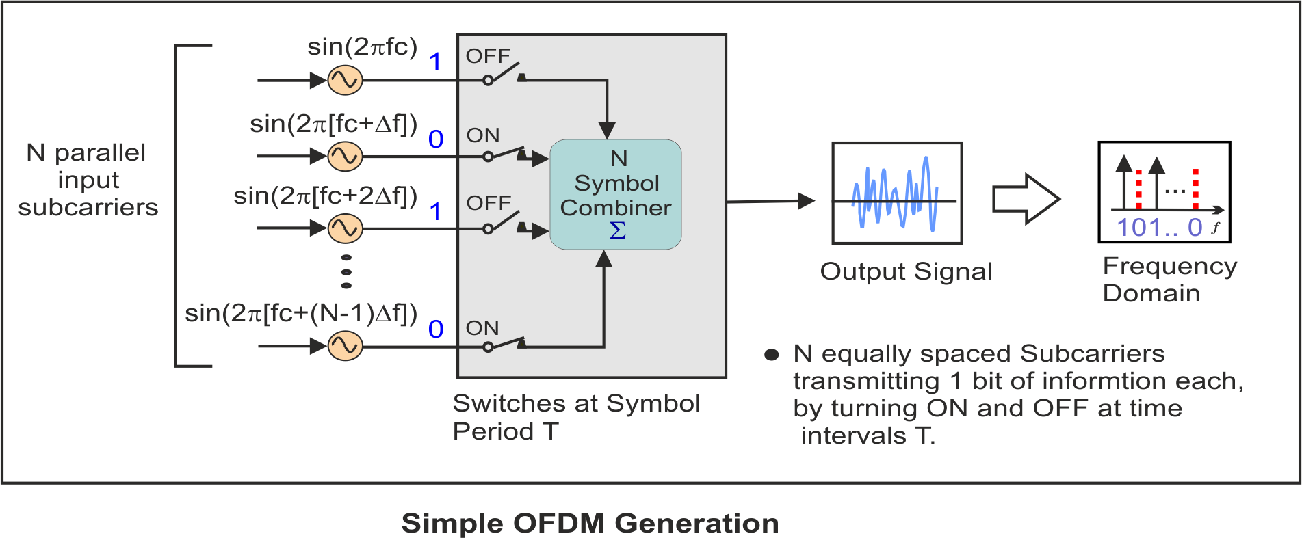

**Understanding Orthogonality – The Importance of Orthogonally Spaced Subcarriers?**

The OFDM signal can be described as a set of closely spaced FDM subcarriers. In the frequency domain, each transmitted subcarrier results in a sinc function spectrum with side lobes that produce overlapping spectra between subcarriers, see "OFDM Signal Frequency Spectra" figure below. This results in subcarrier interference except at orthogonally spaced frequencies. At orthogonal frequencies, the individual peaks of subcarriers all line up with the nulls of the other subcarriers. This overlap of spectral energy does not interfere with the system’s ability to recover the original signal. The receiver multiplies (i.e., correlates) the incoming signal by the known set of sinusoids to recover the original set of bits sent.

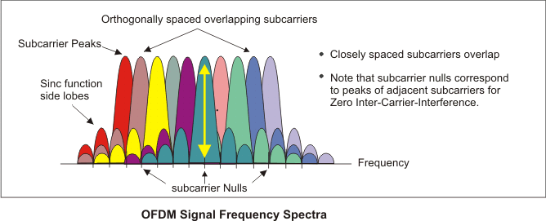

The use of orthogonal subcarriers allows more subcarriers per bandwidth resulting in an increase in spectral efficiency. In a perfect OFDM signal, Orthogonality prevents interference between overlapping carriers. In FDM systems, any overlap in the spectrums of adjacent signals will result in interference. In OFDM systems, the subcarriers will interfere with each other only if there is a loss of orthogonality. For example, frequency error will cause the subcarrier frequencies to shift so that the spectral nulls will no longer be aligned resulting in inter-subcarrier-interference

**Simple Digital OFDM system Implementation using FFT transforms**

The concepts used in the simple analog OFDM implementation can be extended to the digital domain by using a combination of Fast Fourier Transform (FFT) and Inverse Fast Fourier Transform ([IFFT](javascript:void(0);)) digital signal processing. These transforms are important from the OFDM perspective because they can be viewed as mapping digitally modulated input data (data symbols) onto orthogonal subcarriers. In principle, the IFFT takes frequency-domain input data (complex numbers representing the modulated subcarriers) and converts it to the time-domain output data (analog OFDM symbol waveform).

In a digitally implemented OFDM system, the input bits are grouped and mapped to source data symbols that are a complex number representing the modulation constellation point (e.g., the [BPSK](javascript:void(0);) or [QAM](javascript:void(0);) symbols that would be present in a single subcarrier system). These complex source symbols are treated by the transmitter as though they are in the frequency-domain and are the inputs to an IFFT block that transforms the data into the time-domain. The IFFT takes in N source symbols at a time where N is the number of subcarriers in the system. Each of these N input symbols has a symbol period of T seconds. Recall that the output of the IFFT is N orthogonal sinusoids. These orthogonal sinusoids each have a different frequency and the lowest frequency is DC.

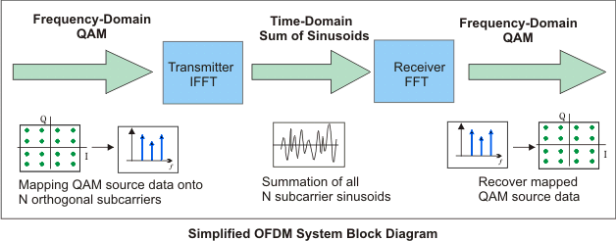

The input symbols are complex values representing the mapped constellation point and therefore specify both the amplitude and phase of the sinusoid for that subcarrier. The IFFT output is the summation of all N sinusoids. Thus, the IFFT block provides a simple way to modulate data onto N orthogonal subcarriers. The block of N output samples from the IFFT make up a single OFDM symbol.

After some additional processing, the time-domain signal that results from the IFFT is transmitted across the radio channel. At the receiver, an FFT block is used to process the received signal and bring it into the frequency domain which is used to recover the original data bits.

**Simple 802.11a OFDM Signal Implementation**

An 802.11a OFDM carrier signal (burst type) is the sum of one or more OFDM symbols each comprised of 52 orthogonal subcarriers, with baseband data on each subcarrier being independently modulated using quadrature amplitude modulation (available formats: BPSK, QPSK, 16-QAM, or 64-QAM). This composite baseband signal is used to modulate a main [RF](javascript:void(0);) carrier.

To begin the OFDM signal creation process, the input data bit stream is encoded with convolutional coding and Interleaving. Each data stream is divided into groups of "n" bits (1 bit -BPSK, 2 bits -QPSK, 4 bits -16QAM, or 6 bits -64QAM) and converted into complex numbers (I+jQ) representing the mapped constellation point. Note that the bit-rate will be different depending on the modulation format, a 64-QAM constellation (6 bits at a time) can have a bit rate of 54 Mbps while a QPSK constellation (2 bits at time) may only be 12 Mbps.

Then 52 bins of the IFFT block are loaded. 48 bins contain the constellation points which are mapped into frequency offset indexes ranging from -26 to +26, skipping the 4 Pilot and zero bins. There are 4 Pilot subcarriers inserted into frequency offset index locations -21, -7, +7, and +21. The zero bin is the Null or [DC subcarrier](javascript:void(0);) and is not used; it contains a 0 value (0+j0).

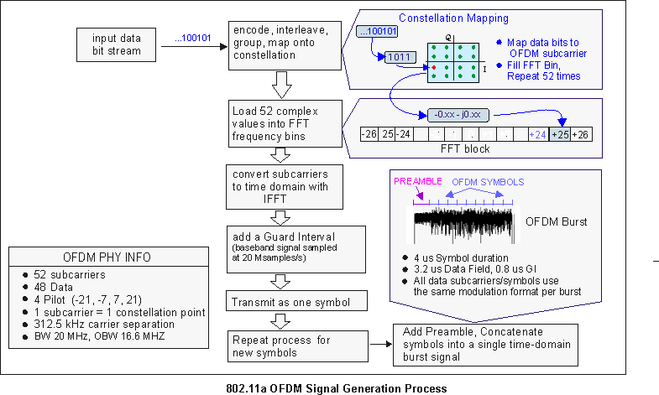

When the IFFT block is completely loaded, the Inverse FFT is computed, giving a set of complex time-domain samples representing the combined OFDM subcarrier waveform. The samples are clocked out at 20 Msps to create a 3.2 us (20Msps/64) duration OFDM waveform. To complete the OFDM symbol, a 0.8 us duration Guard Interval ([GI](javascript:void(0);)) is then added to the beginning of the OFDM waveform. This produces a "single" OFDM symbol with a time duration of 4 us in length, (3.2 us + 0.8 us). The process is repeated to create additional OFDM symbols for the remaining input data bits.

To complete the OFDM frame structure, the single OFDM symbols are concatenated together and then appended to a 16 us Preamble (used for synchronization) and a 4 us SIGNAL symbol (provides Rate and Length information). This completes the OFDM frame and is ready to be transmitted as an OFDM Burst.

**See Also**

[802.11 OFDM WLAN Overview](http://rfmw.em.keysight.com/wireless/helpfiles/89600B/WebHelp/Subsystems/wlan-ofdm/Content/ofdm_80211-overview.htm)

[About 802.11a/g/j/p OFDM Modulation Analysis](http://rfmw.em.keysight.com/wireless/helpfiles/89600B/WebHelp/Subsystems/wlan-ofdm/Content/ofdm_about_option_b7r_ofdm_demodulation.htm)

|  |  |
| --- | --- |
| Copyright © 2000-2019 Keysight Technologies, Inc. | [http://rfmw.em.keysight.com/wireless/helpfiles/89600B/WebHelp/Subsystems/wlan-ofdm/Content/resources/image/common/sendfeedback.png](javascript:sendFeedback();) |